**Advising System**

**Project management: Team Plan (Jan 26th)**

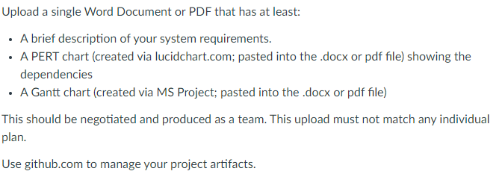

**Requirement Gathering: Domain Model (Feb 2nd)**

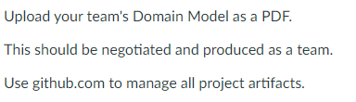

**High level design: Use Case Model (Feb 9th)**

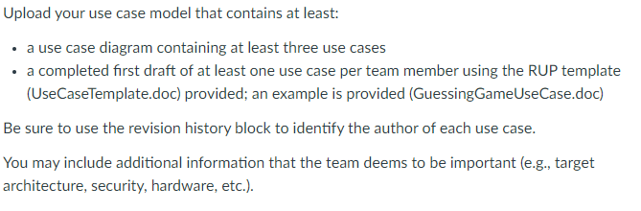

**Low level design: Analysis Model (Feb 16th)**

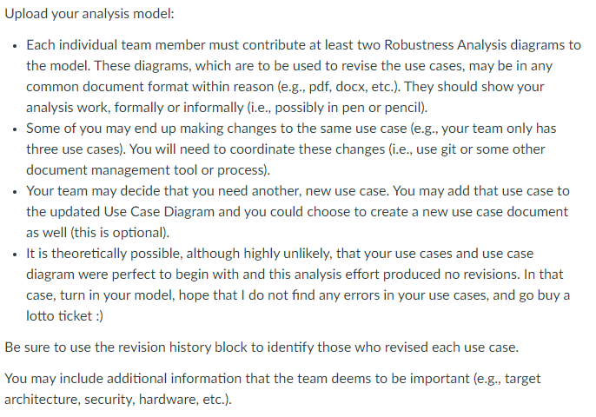

**Testing: Baseline (Mar 2)**

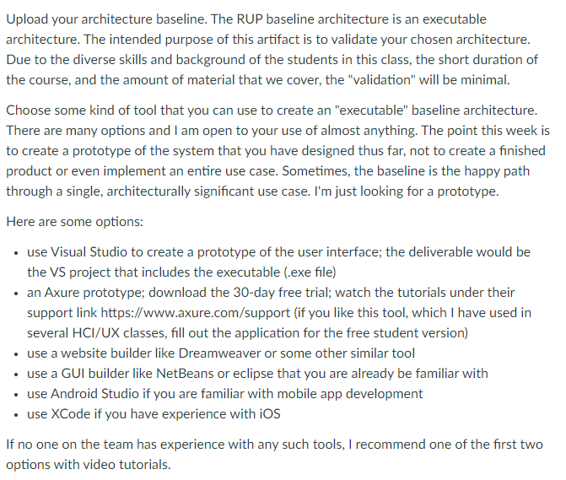

**Deployment: Deployment plan (March 9th)**

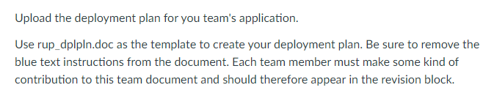

**Metrics: Contingency (March 16th)**

